

**DEPARTMENT OF COMPUTER SCIENCE & ENGINEERING**

**SHARDA SCHOOL OF ENGINEERING AND TECHNOLOGY SHARDA UNIVERSITY, GREATER NOIDA**

**IoT Based Third Eye for the Stone Blind**

***A project submitted in partial fulfillment of the requirements for the degree of Bachelor of Technology in Computer Science and Engineering***

**by**

**Sarah Irshad (2019574108) Pravidhi Garkoti(2019002136) Ankit Sharma(2019007635)**

**Supervised by:**

**Prof. (Dr.) Parma Nand (Dean, SET) and**

**Dr. Mandeep Kaur (Professor, SET)**

**MAY , 2023**

# CERTIFICATE

This is to certify that the report entitled **“**IoT Based Third Eye for the Stone Blind**”** submitted by **“Sarah Irshad”, “Pravidhi Garkoti” and “Ankit Sharma”** to Sharda University; towards the fulfillment of requirements of the degree of **“Bachelor of Technology”** is record of bonafide final year Project work carried out by them in the **“**Department of Computer Science & Engineering, Sharda School of Engineering and Technology, Sharda University**”**. The results/findings contained in this Project have not been submitted in part or full to any other University/Institute forward of any other Degree/Diploma.

**Signature of the Guide**

**Name:** Prof. (Dr.) Parma Nand

**Designation:** Dean, SET

## Signature of the Co-Guide

**Name:** Dr. Mandeep Kaur

**Designation:** Professor, SET

**Signature of Head of Department Name:** Prof.(Dr.)Nitin Rakesh

**Place:** Sharda University

## 

## Signature of External Examiner

## Date:

# ACKNOWLEDGEMENT

A major project is a golden opportunity for learning and self-development. We consider ourselves very lucky and honored to have so many wonderful people lead us through in completion of this project.

First and foremost we would like to thank Dr. Nitin Rakesh, HOD, CSE who gave us an opportunity to undertake this project.

Our grateful thanks to Prof. (Dr.) Parma Nand and Dr. Mandeep Kaur for their guidance in our project work. Prof. (Dr.) Parma Nand and Dr. Mandeep Kaur, who in spite of being extraordinarily busy with their academics, took timeout to hear, guide and keep us on the correct path. We do not know where we would have been without their help.

CSE department monitored our progress and arranged all facilities to make life easier. We choose this moment to acknowledge their contribution gratefully.

Name and signature of Students:

## SARAH IRSHAD (2019574108)

**PRAVIDHI GARKOTI (2019002136)**

**ANKIT SHARMA (2019007635)**

# ABSTRACT

Eyes are the primary sense organs for seeing the outside world; their failure has a significant impact on the outside world's knowledge perceiving capability. As the technologies get advanced we can now enjoy most of the comforts as normal humans but visually impaired people cannot. Blind people usually depend upon specific support or help for them to do their daily work. They continue to face a variety of challenges in their lives. The proposed solution is a wearable bag for people with visual impairments that can support them in navigating challenges and barriers and tracking their coordinates, which is then sent to a particular member of the family. This will be adorned with ultrasonic sensors made up of software components. The proposed technology works as athird eye for blind people because they have outstanding senses. A vibrator sensor is used in the band

to provide vibration in their hand whenever a component is nearby.

According to a World Health Organization research and data sheet on vision loss that was revised in October 2017, there are approximately 253 million people who have impaired vision; 36 million are completely blind, while 217 million are partially blind. According to a 14 October 2021 news piece, the worldwide number of individuals with near as well as proximity vision impairment has expanded to 2.2 billion. Millions around the world have mild to high visual impairments. The chronic and progressive disease remains the major cause of visual impairment worldwide .Whereas the two highest causes of vision loss are Astigmatism faults which have not been repaired and cataracts which have not been acted on In this case

Also when the sensor detects any object the buzzer will make sound. Therefore it is an automated device. The blind person's present position will be communicated to a particular person, who will be capable of locating individuals if they get lost and safeguarding them. This band will be of excellent assistance to blind individuals with regards to automatic identification and daily use.

***Keywords—IOT (internet of things), Stone Blind, Ultrasonic Sensor, GPS, GSM***

## CONTENTS

TITLE i

CERTIFICATE ii

ACKNOWLEDGEMENT iii

ABSTRACT iv-v

LIST OF FIGURES vii-viii

LIST OF TABLES ix

CHAPTER1: INTRODUCTION… 1

* 1. Motivation 1
  2. Overview… 2
  3. Expected Outcome 3
  4. SRS 3

CHAPTER2: LITERATURE SURVEY… 6

* 1. Existing Work 6
  2. Specified Pros and Cons for betterment 10
  3. Feasibility Study 15
  4. Proposed System 16

CHAPTER3: SYSTEM DESIGN & ANALYSIS 19

* 1. Project Perspective 19
  2. Performance Requirements 19
  3. System Features 20
  4. Methodology 21
  5. Testing Process 27

CHAPTER4: RESULTS AND OUTPUTS 33

* 1. Proposed Model Outputs 33
  2. Expected Budget of the third eye 36

CHAPTER5: CONCLUSION… 37

* 1. Conclusion 37
  2. Future Scope 37
  3. Limitation 37

**References Annexure 1**

**Annexure 2**

# LIST OF FIGURES

|  |  |  |
| --- | --- | --- |
| **Figure Number** | **Title** | **Page No.** |
| Fig 2.2.1 | Pie chart for Moderate VI | 14 |
| Fig 2.2.1 | Pie chart for Blindness | 15 |
| Fig2.3.1 | Component Diagram of the Proposed System | 17 |
| Fig2.3.2 | Flowchart of the Proposed System | 18 |
| Fig 3.4.1 | Prototype In the Bag | 22 |
| Fig.3.4.1.1 | Arduino Uno | 23 |
| Fig.3.4.2.1 | Ultrasonic Sensors | 24 |
| Fig.3.4.3. | Buzzer | 24 |
| Fig.3.4.5.1 | GPS | 25 |
| Fig.3.4.8.1 | Lithium-Ion Battery | 27 |
| Fig 3.5.2 | The device in the water resistant box | 28 |
| Fig 3.5.2.1 | System case Diagram | 31 |
| Fig 3.5.2.2 | User Case Diagram | 32 |
| Fig.4.1.1 | Setup Model | 33 |

|  |  |  |
| --- | --- | --- |
| Fig.4.1.2 (a) | Working Model | 34 |
| Fig.4.1.3 (b) | Working Model (Switched ON) | 34 |
| Fig.4.1.4 | Third Eye in the bag | 35 |
| Fig.4.1.5 | Message Received | 36 |

# LIST OF TABLES

|  |  |  |
| --- | --- | --- |
| **Table No** | **Title** | **Page No** |
| Table 2.1.1 | Existing Systems | 6-9 |
| Table 2.2.1: | Existing Systems | 10-13 |
| Table 3.2.1 | Device performance | 19 |
| Table 3.2.2 | Battery performance | 20 |

## CHAPTER1: INTRODUCTION

A revised World Health Organization research and data sheet on vision loss estimates that 253 million individuals worldwide have vision impairment, of which 217 million are partially blind. 36 million of them are completely blind. According to a news report dated October 14, 2021 [1],

2.2 billion individuals worldwide suffer from close-up and proximity vision impairment. Mild to severe visual issues affect millions of people globally. Globally, chronic, progressive sickness continues to be the leading cause of vision loss. In today's extremely competitive climate, those with vision impairments are not given the respect they merit since they are disregarded.

The major goal of this programme is to assist people who are blind or visually impaired by using technology to improve their lives, make the world a more just and secure place for them, and lessen their vulnerability so they may go about their everyday lives on their own. This technology may act as an inner eye for the blind since it combines GPS, which makes it simple to discover directions by only hearing audio, with the capacity to discern between things, which helps a person who is legally blind to avoid collisions and move around freely.

Keeping a dog as a pet is a second strategy that, despite being expensive, has benefits [2]. Our idea, third eye for the stone blind, will be created to enable the blind person to navigate around with assurance and more interest. It is a brilliant invention that handles every problem. Numerous amazing discoveries and methods are already available for those who are physically disabled.

Although most of this equipment has helped blind people, there are some drawbacks, such as the fact that they require a lot of planning and administration. Blind people can now live independently and confidently go about their daily lives thanks to the band for the blind. The objective of this project is to develop a product that will be incredibly beneficial for blind individuals who constantly rely on others. Through the use of a worn band that emits a buzzing sound or other sensations, the third eye for the Blind's initiative enables blind people to move quickly and confidently from one place to another. A GPS tracking gadget is also added for the benefit of blind individuals.

## MOTIVATION

According to the research and data sheet on vision loss from the World Health Organization, which was updated in October 2017, there are about 253 million individuals with vision impairment, of whom 217 million have moderate impairment and 36 million are entirely blind. According to statistics released on October 14, 2021, there are 2.2 billion persons who are currently affected by near- or distance-vision impairment globally.1.

Mild to severe visual impairments affect millions of people worldwide. Globally, chronic and progressive diseases continue to be the main contributors to vision loss. In this scenario, untreated cataracts and astigmatism issues are the main causes of vision loss. People with vision issues are ignored and treated disrespectfully in today's fast-paced society.

The main goal of this project is to help blind or visually impaired individuals enjoy independent lives by using technology to enhance their quality of life and make the world safer and more secure for everyone. Given that it combines GPS, which makes it simple to determine directions by only hearing audio, with the ability to distinguish between objects, which enables a person who is legally blind to avoid collisions and move around freely, this technology may serve as an inner eye for the blind.

## OVERVIEW

* + - The proposed solution is a third eye bag for the blind that helps with obstacle detection and location tracking before transmitting the information to a chosen family member.
    - The proposed device acts as a third eye for blind persons since they have keen sensory abilities; a vibrator sensor is placed in the band to vibrate their hands when an object is nearby.
    - When the sensor detects something, the buzzer will also activate.
    - To put GPS tracking into practice for blind individuals. Due to their keen senses, blind persons can profit from the proposed technology as a third eye. When an object is nearby, the vibrator sensor in the band causes the wearer's hand to quiver.
    - The project's main goal is to close the technology gap and utilize existing technology as effectively as possible to create a tool that enables the society's stone-blind members transcend part of people's everyday lives.
    - The proposed project calls to construct a third eye, which will require Arduino Uno boards, two ultrasonic sensors to cover the entire 360-degree field of view, GPS GSM to provide directions, buzzers, as well as a battery like those found on contemporary smart watches.
    - The concept is built around an amazing wearable device that can be used as a band or as blind material and is powered by an Arduino board.

## EXPECTED OUTCOMES

The goal is to develop a device that will assist stone blind people in overcoming obstacles in their daily lives. The device would be in the shape of a band rather than a stick because it would be more practical, user-friendly, and tasteful to use. It would include an Arduino- Uno, ultrasonic sensors; a lithium-ion battery, buttons, GPS, and GSM that will help locate the user. This device will make it possible for all visually impaired people to complete their daily tasks independently and will be accessible worldwide since it will be less cost effective and simpler to discover in the market.

* Research paper published.
* Patent Application will be Submitted.
* IoT based Third eye (band) Hardware Completed
* Applied for Multiple Hackathons

## SRS

* + 1. **Project Overview**

In accordance with a news article from October 14, 2021 [1], 2.2 billion individuals worldwide suffer from close-up and proximity vision impairment. Mild to severe visual issues affect millions of people globally. The most frequent reason for visual loss is still persistent, progressive sickness on a global scale. In today's fiercely competitive environment, people with vision impairments are not given the attention they deserve.

The major goal of this program is to support blind or visually impaired individuals by utilizing technology to improve their lives, make the world a more just and secure environment for them, and lessen their vulnerability so they may go about their everyday lives on their own. The white cane, intelligent cane, and infrared cane are just a few of the numerous cane designs that are currently offered. These technologies are subject to some limitations, though.

The length of the cane makes it challenging to hold and use in public settings. The cane's capacity to recognize obstructions is also constrained. Recently, many cutting-edge techniques have been developed to enhance the movement of blind people. Utilizing sensors and signal processing technology, these methods were developed. But when there is a lot of electronic wave activity or in crowded areas, these devices frequently break down. A simple, efficient, and adaptable electronic guided embedded vision system is used in this work to help the movement of blind and visually impaired people.

The system uses three different kinds of gadgets, including an Arduino-uno, an ultrasonic sensor, and a GPS and GSM module. To classify an obstruction, an Arduino -Nano microcontroller

analyzes the reflected signals from every device. The suggested guidance system can estimate the distance to obstacles and provides voice alerts through headphones to the user. The system can also identify some of the users' live locations and send messages to those who are close to them.

Furthermore, the user is not required to carry a cane or another tool with markings. It is a brilliant invention that handles every problem. Presently, numerous excellent breakthroughs and approaches are available to those with limitations in their bodies. Blind people can now live lives of independence and effortlessly carry out their everyday activities because of the bag for the blind.

Our project aims to create a product that will be very beneficial to blind people who depend on others all the time. The third eye for the Blind's work uses a used bag that makes a buzzing sound or other sensations to assist blind people in moving quickly and confidently from one place to another. A GPS tracking device is also made available for the safety of blind people so they can always be found.[3][4].

## Non-Functional Requirements (a)Extensibility:

Extensibility is the design principle that defines whether a system can be expanded. The expansion could consist of new functionality or a change to already-existing functionality. The system is improved overall without impairing current operational features. A simple device that can be accessed by people easily and is budget friendly.

## Maintainability:

The ability of users to alter a system and fix any flaws is known as maintainability. It also decides how to enhance efficiency and recovery of errors while adding new features. For a system to be maintained, constant improvement is typically necessary. Extensibility and maintainability are strongly related. The system in this project is basic and modular.

## Performance:

Performance is assessed using following specifications:

1. Response time: Response time is the length of time it takes a system to accept user input and reply by presenting some output. Typically, third eye gives the buzzer sound and headphones are used for voice messages to announce the availability of an object near the person.
2. Workload: The system's capacity for stress or work is referred to as the workload. The setup needs to be charged after all the functions are done and can easily handle it for 24 hr.

## Hardware Specification

1. **for Construction of Third Eye**
   1. Wires
   2. Wrist Band
   3. Battery-Lithium Ion (300mAh-500mAh)
   4. Buzzers
   5. Vibrator Motor
   6. Power Adapter

## IoT-based device:

* 1. Arduino-Uno board
  2. Ultrasonic Sensors
  3. GPS
  4. GSM
  5. Monitor
  6. Keyboard
  7. Mouse

## Software Specification

For the communication between the devices: Embedded C and

Arduino-Software

## CHAPTER2: LITERATURE SURVEY

## EXISTING WORK

Blind people can swiftly and predictably experience reality with the use of a technology tool known as the "third eye" for the blind. Customers are informed either audibly or vibratory when nearby impediments are found using ultrasonic waves. It is supported by a variety of industries, such as computer science, device design, and health care. [3]. Because of technological advancements, most luxuries are now available to us commoners, but not to blind people. People who are blind usually require specialized assistance or help with everyday tasks. Many challenges still plague them in their day-to-day lives.[4].

In the past several years, a variety of techniques and tools that enable blind individuals to move freely and independently about their surroundings without the help of another person have developed and changed. While few and limited, there are certain restrictions. [7, 8]. Table 1 displays the responses from diverse scholars in several different ways. The goal of this research project is to create a blind person's backpack with a GPS system to track their whereabouts and an ultrasonic sensor to detect impediments and warn the user by vibrating or buzzing.

## Table 2.1.1: Existing Systems

|  |  |  |  |
| --- | --- | --- | --- |
| **S.No** | **YEAR** | **OBJECTIVES** | **FINDINGS** |
| 1 | 2018 | To develop a special wearable that makes use of the Arduino board and may be used as a band or blinds cloth. | It was efficient to use and  help blind people find direction by buzzer sound and vibrations. |
| 2 | 2018 | This study describes a novel wearable navigation system for blind and visually impaired people that combines tactile foot stimulation for information presentation with GPS | The method makes use of a smartphone's GPS coordinates. By processing GPS data and calculating the best route to take, specialized navigation software  provides guidance to a destination. |

|  |  |  |  |
| --- | --- | --- | --- |
| 3 | 2019 | The classification of the obstruction was done using the ultrasonic sensor's distance measurement, the neural network, and multiple correlation, while obstacle detection was done using multiple correlation. | It is determined that the ultrasonic sensor was able to recognize the five types of obstruction that were mentioned. |
| 4 | 2020 | The proposed system deals with the  obstacle detection using stick and  Raspberry pi. | By supporting their movement whether they are indoors or outside. |
| 5 | 2021 | The proposed system deals with the  cheaper and effective obstacle detection with a wide range of coverage. | Finding the distance between the objects and the sensor using the system was very simple. |

|  |  |  |  |
| --- | --- | --- | --- |
| 6 | 2021 | To Build Navigation System for Blind | By facilitating their movement whether they are indoors or outside, it enables blind and visually impaired persons to be very independent. |
| 7 | 2021 | A camera-based structure for assisting with content browsing is the proposed system, which aims to impress users. | It aids the blind in correctly identifying and recognizing. Additionally, it voice-overs text. |

|  |  |  |  |
| --- | --- | --- | --- |
| 8 | 2022 | The project is a left glove that the user wears. To start the gloves activity, the user must point his hand in the direction of the beeping gloves to determine whether there are any handicapped things nearby. Any object that is turned on its side triggers an alarm in gloves. Additionally, it sounds an alarm whenever a user is in front of an object. The central Arduino system will receive obstacle data from the ultrasonic sensor, which will also determine the user's distance from the obstruction in order to activate the vibrator. | The concept is to create an Ultra Sonic Glove to aid the blind avert these mishaps with a low-cost module in order to help them avoid fatal accidents and frequent collisions with things around them. The goal of this research was to provide a mobility aid for those who are blind. |
| 9 | 2022 | voice assistant, camera module, speech recognition, object detection, pi operating system. | This project's entire concept has been created a basic glove has fewer functions because it is impractical to fit several different types of modules into a small glove. |

The research paper's concrete goals are to identify targets, inform the user of their appearance, calculate the participant's distance from obstructions, and notify the individual when that distance gets closer to a vital juncture. It will also keep track of the bag's whereabouts in the event it is misplaced or if the consumer is in an extreme situation.

## SPECIFIED PROS AND CONS FOR BETTERMENT

The advantages and disadvantages of previous study findings on the third eye are shown in the table below, which will help to provide a clearer understanding of the work that has already been done. It will also help us to improve the third eye by taking advantage of the pros and resolving and improving the shortcomings that arose in earlier studies by employing current technologies. By carrying out such work, we can improve the third eye so that it is widely accessible on the market and is simple for users to use.

## Table 2.2.1: Existing Systems

|  |  |  |  |
| --- | --- | --- | --- |
| **YEAR** | **OBJECTIVES** | **PROS** | **CONS** |
| 2018 | To design a basic, simplistic, incredibly user-friendly electronic guidance system with many more capabilities for blind persons. | The blind person can use this to investigate and avoid items to their left, right, and in front of them regardless of the height or intensity of the objects. | Because the ultrasonic sensor is inadequate, finding difficulties takes time. |
| 2018 | Create a third eye tool using an Arduino Wearable Pro Mini Board. | It is a simple-to-use tool that can quickly locate any obstacles. | Beyond simply pointing out roadblocks, this technology does not aid the blind in any other manner. |

|  |  |  |  |
| --- | --- | --- | --- |
| 2019 | This technology does not assist the blind in any way other than pointing out obstacles. | This AI-based system offers an easy-to-use, customizable electronic guided embedded visual system. | All of the Raspberry Pi's CPU power is used for object detection, which is bad for users and makes the gadget rather heated. |
| 2019 | Utilizing an Android app with machine learning that is Bluetooth-attached, the third eye application | Identifying hurdles and understanding the area's surroundings and colleagues are two advantages. |  |
| 2020 | Third eye navigation systems for blind people | Compared to preceding science and technology, this one is faster | The accuracy and range of Bluetooth-enabled devices weren't addressed in this investigation, which may cause a blind person to feel confused given that they periodically deliver unreliable data. |

|  |  |  |  |
| --- | --- | --- | --- |
| 2020 | Optically Individuals who are disabled can test their velocity and trust by understanding a place where ultrasonic healing is currently utilized to get around obstructions waves, and then receiving instructions with a frequency mannerisms or sensation. | By using this piece of equipment, the blind may completely disregard the usage of the white stick and other similar instruments. This tool will allow blind individuals to move around without having to grasp a stick, which may drive them crazy. | It just states the fundamental impediment without specifying its direction. The buzzer may annoy the user, and it will only get worse because it won't turn off until the user is down instantly from the resistance. |
| 2021 | in order to set up a blind tracking system |  | The spectrum of the technology demo’s  electronics is not exceptionally broad. |
| 2021 | Utilize cutting-edge technologies to assist the blind. |  | Assist the blind The seriously crippled can determine the importance of the post, enabling the volunteers to provide assistance right away. Users who are blind can upload any images to help them understand the message. Additionally, to gauge the credibility of the recipient |

|  |  |  |  |
| --- | --- | --- | --- |
| 2022 | The development of a blind people's Arduino stick |  |  |
| 2022 | It describes an ultrasonic sensor that can determine how far away from the ground certain places on a moving vehicle are. |  |  |

The challenges which are faced in the current system.

1. White cane a stick for blind - Rapidly fractures or gaps, and its tines may get caught in multiple discrepancies in the sidewalk.
2. Dogs that are pet-friendly are expensive. (~$42,000 / 280000Rs)
3. Typical Drawbacks (Including Intelligent Technology) demands a lot of education for individuals and cannot be carried at face value.

The Pie-chart shows the causes of visual impairment among those who had moderate visual impairment and blindness.

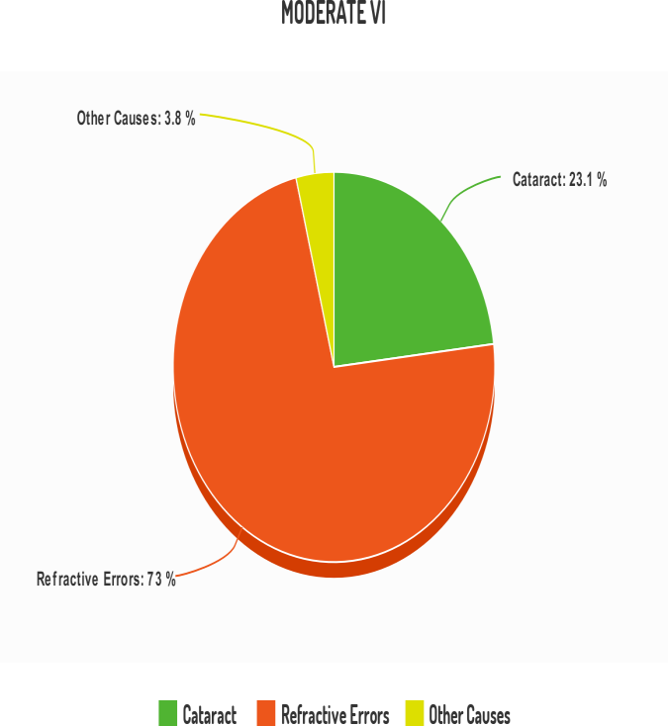

**Fig 2.2.1:** Pie chart for Moderate VI

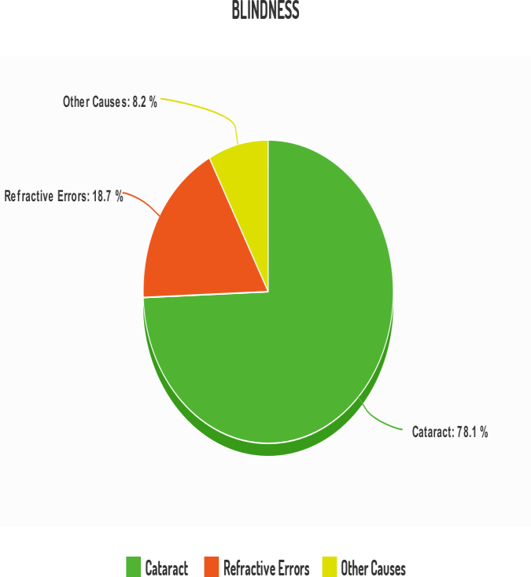

**Fig 2.2.1:** Pie chart for Blindness

## FEASIBILITY STUDY

A system's "feasibility study" is an assessment based on factors such as usability, organizational impact, user-satisfaction potential, and resource efficiency. We can use a variety of conditions to test our system. Here, possible outcomes are divided into three categories. Here are a few examples:

## Technical Feasibility:

A review of resource availability in relation to the potential to create a sustainable model, this evaluation looks at the availability of the technology needed for the suggested system. This system might be developed using IoT-based relevant information, along with some of the hardware expertise needed to build the suggested system and some of the technological expertise needed to develop a User-level device.

## Economic feasibility:

It must still be financially advantageous for the User to invest in a system that is technically feasible and will be used if it is deployed. The economic feasibility analysis compares the system's development costs to the benefits that will ultimately result from new systems. The monetary advantages have to justify the costs or be in some way comparable to them. The undertaking is attainable financially. The valuation is reasonable and valid, even though extra gadgets are needed. Because modern materials and technology were used to manufacture the apparatus for this kind of system. For certain things, there is a reasonable investment and financial sustainability.

## Operational Feasibility:

The value of proposed initiatives depends on their viability as an information system. This will meet the operational needs of the User. Operational feasibility components of the project are to be considered as an important problem highlighted is to test the operational feasibility of a project consists of the following: Is the Device providing the User with enough support?

Will the system be used and work properly if it is planned and put into place?

Is there a chance that user opposition will undermine any potential application advantages?

The goal of this approach is to be consistent with the initial problems. Prior to that, customer requirements but also market issues were considered as well. As a result, there is no chance that user opposition will destabilize the potential benefits of the implementation. A well-thought-out design would guarantee effective use of the resources and help to improve overall effectiveness.

## PROPOSED SYSTEM

The system that has been proposed is a set of wearable for people with vision impairments that can guide them around barriers and send information about their whereabouts to a designated member of their immediate family. Due to their dedicated senses, the proposed system functions as a third eye for blind people. When an object is close by, the vibrator sensor in the band vibrates the wearer's hand. Additionally, the buzzer will sound when the sensor picks up any object.

The suggested method addresses the issue of cheaper and more effective obstacle and live position detection with navigation detection across a large range of coverage. The following is component diagram of the proposed system included in the device:

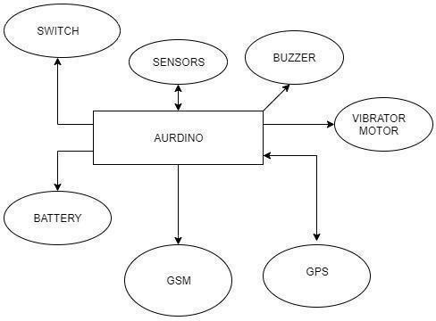

**Fig2.3.1:** Component Diagram of the Proposed System

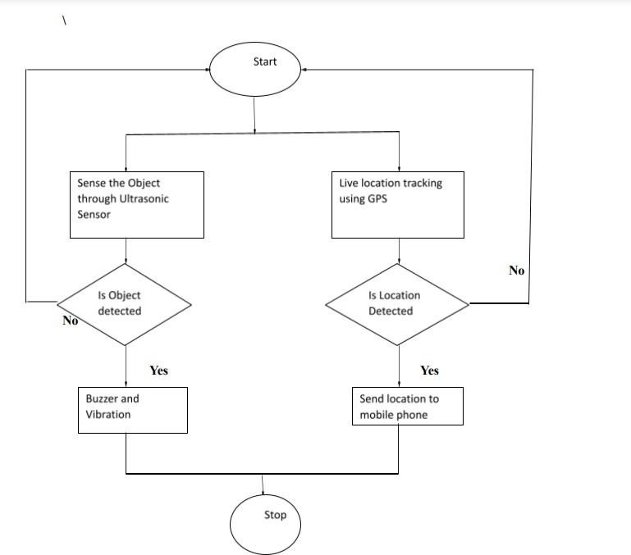

## Fig2.3.2: Flowchart of the Proposed System

**CHAPTER 3: SYSTEM DESIGN & ANALYSIS**

## PROJECT PERSPECTIVE

Several technologies and methods to assist blind people in achieving independent or unhindered mobility around their environment without the guidance of another person have evolved and innovated in recent years.. There are a handful of criteria, but they are restricted by limitations and drawbacks.

The project's main goal is to close the technology gap and utilize existing technology as effectively as possible to create a tool that enables the society's stone-blind members transcend part of people's everyday lives. So it would be more useful, user-friendly, and aesthetically pleasing to use, the gadget would be influenced like a band as appeared differently in relation to a stick. It would have a lithium-ion battery, an Arduino-Uno, ultrasonic sensors, buttons, GPS, and GSM that would help locate the user. Due to its low cost and ease of use, this device will enable all blind people to carry out their daily tasks on their own and will be available to everyone worldwide.

## PERFORMANCE REQUIREMENTS

Quality requirements are the different facets of a system's operating condition, upkeep, and steadfastness that are calculated to be essential for it to satisfy the requirement by which it is designed.

## Device performance:

**Table3.2.1: Device performance requirement**

|  |  |
| --- | --- |
| **Angle for detection** | 360 Degree |
| **Range of sensor** | 2cms-4m |
| **Frequency of buzzer** | 12.5 Hz |

## Battery performance:

**Table3.2.2: Hardware performance requirement**

|  |  |
| --- | --- |
| **Lifetime cycle of battery** | 2-3 years |
| **Battery capacity** | 2600mAH |
| **Battery voltage** | 3.7 v |

## SYSTEM FEATURES

This project deals with the development of a deployable IoT-based GPS module for the blind – Third Eye – that improves the visual impairment communities and facilitates their everyday movements. By articulating their environments, the third eye enables the visually impairedcommunity a novel approach for seeing the world. The complete system is controlled by the Arduino -Uno board. The strategy relies on a remarkable wearable device powered by the Arduino board that may be worn as a band or material for blinds.

The proposed project entails the construction of a third eye that will need Arduino Uno boards, two ultrasonic sensors to cover the full 360 degree that will measurethe distance to an object using ultrasonic sound waves, GPS GSM to give the directions, buzzers and a battery that are used in smart watches nowadays.

The existing system only detected the object that can cause hindrance for the visually impaired individual. The suggested system is simple to deliver which will not only detect the distance of the object and identify but can be also used for navigating the routes, the individual will be able to detect the paths by just hearing the sounds which will direct the path. Figure 3 below gives the glimpse of the prototype of the gadget.

## METHODOLGY

The suggested technique is designed to assist blind people in locating obstacles and tracking their location, which is then communicated to a specific family member. Since blind people have keen senses, the suggested technology acts as a third eye; a vibrator sensor is embedded in the band to stimulate their hands when an object is nearby. The buzzer will also ring when the sensor detects something.

The purpose of this endeavor is to create the deployable Third Eye IoT-based GPS module for the blind, which will benefit communities of people with visual impairments and make daily activities easier for them. By articulating their surroundings, the third eye offers the blind people a novel perspective on the outside world. The Arduino -Uno board manages the entire system. The plan is based on a stunning wearable that can be used as a band or as blind material and is powered by an Arduino board. The current proposal calls for building a third eye, which will require Arduino Uno boards, two ultrasonic sensors to cover the entire 360 field of view, GPS GSM to provide directions, buzzers, and a battery similar to those found in modern smart watches.

Ultrasonic sensors measure distance to an object using sound waves. The current system only picks up on objects that could be problematic for someone who is blind. The suggestedsystem is easy to implement and will not only measure an object's distance and identify it, but it can also be used to find one's way around. The user will be able to find their way by simply hearing the sounds that will point them in the right direction. Figure below shows a glimpse of the device's prototype. With a lesser cost and enhanced performance for impediment and live position detection, the proposed methodology addresses the problem of strafing identification across a wide network spectrum.

The recommended method examines the issue of navigation detection across a broad range of coverage with cheaper and more effective obstacle and live location detection. The gadget consists of the following parts:

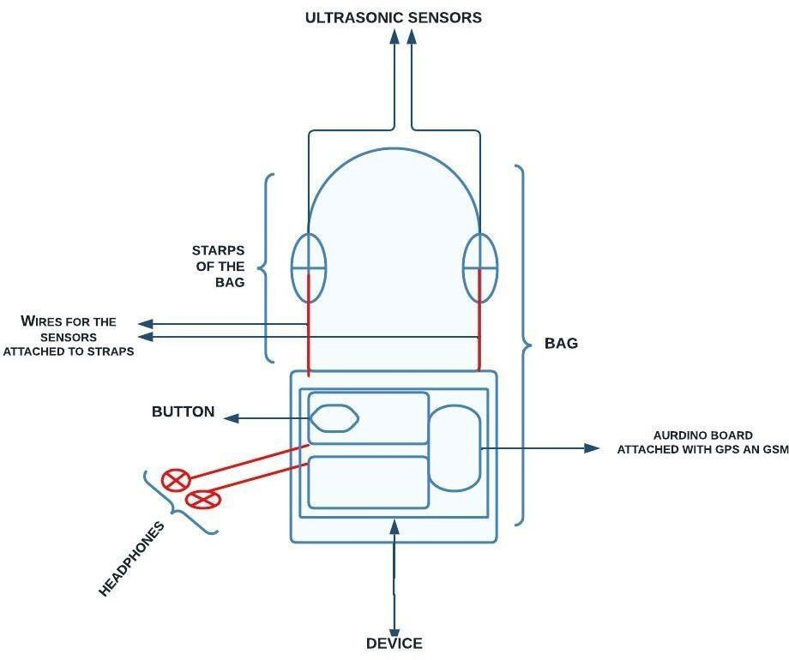

## Fig 3.4.1: Prototype In the Bag

* + 1. **Arduino-UNO:**

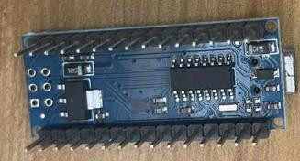One of Arduino's standard boards is the UNO. The Italian word UNO here is for "one." To identify the very first version of the Arduino Software, it was given the moniker UNO. It was also the first USB board that Arduino had ever produced. The ATmega328P (ATmega328P) microprocessor is the building block of the Arduino UNO. Compared to other boards, like the Arduino Mega board, etc., it is simple to use. The board is made up of shields, various circuits, and digital and analogue Input and Output (I/O pins. The Arduino UNO has 14 digital pins, a USB port, a power jack, and an ICSP (In- Circuit Serial Programming) header in addition to 6 analogue pin inputs. It is written in accordance with IDE, or integrated development environment.

**Fig.3.4.1.1. Arduino Uno**

## Ultrasonic Sensors:

In order for ultrasonic detectors to operate effectively, a sound wave above the capabilities of human perception needs to be transmitted out. The sensor's transducer serves as a microphone for receiving and transmitting ultrasonic noise. Like many others, our ultrasonic sensors use a single transducer to transmit a pulse and receive the echo. By monitoring the amount of time that happens between delivering and receiving an ultrasonic pulse, the sensor is capable of determining the amount of time to a target.

1. Not affected by object color and transparency as it detects distance through sound waves.
2. 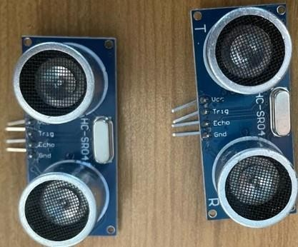Applicable for daytime and nighttime usages
3. One more thing is that, in case of IR sensor, we need low lighting condition. But with ultrasonic sensors we don't have to worry about extra light.
4. Accurate calculations.
5. Can be used inside/outside.

Does not get affected with external sources such as sunlight.

1. Does not refract/does not pass through. **Fig.3.4.2.1. Ultrasonic Sensors**
   * 1. **Buzzers:**

A magnetic field can be generated in a magnetic buzzer by pumping current around a coil of wire. When the current is there, a flexible ferromagnetic disc draws electricity to the coil; when the current is absent, the disc returns to its "rest" position. Contrary to piezoelectric buzzers (12–220 V, 20 mA), magnetic buzzers function at lower voltages and greater currents (1.5–12 V, > 20 mA). Similar to how the cone in a speaker makes sound; the rotation of the ferromagnetic disc in a magnetic buzzer produces sound. The voltage that is utilized and the coil's impedance affect how many current flows through it.

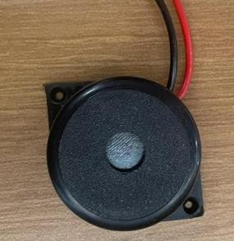

**Fig.3.4.3.1. Buzzer**

## Vibrator Motor:

A coin vibration generator is employed in intelligent wristwatches. Smart timepieces, fitness trackers (like the one observed on the right image), and other electronic devices can rely on coin vibratory drivers. They have a tendency for offering the user precise warnings, realistic alerts, or tactile input. With a peak speed of 10m/s2 and frequency of 12.5Hz, the movement in smart watches vibrates between 170Hz and 240Hz [19, 20], so this is lower in frequency and less dangerous to the individual using it.

## A picture containing text, electronics Description automatically generatedGPS (Global Positioning System):

As seen in fig. 7 the Global Positioning System (GPS), which offers positioning, navigation, and timing (PNT) services, is owned by the United States. GPS devices have been enhanced by IoT technology to connect to other systems and sensors and communicate data over vast distances. Modern tracking systems are able to collect and send comprehensive vehicle data, such as driver identification, remote temperature monitoring, and

fuel monitoring. **Fig.3.4.5.1.GPS**

## GSM (Global System for Mobile Communications):

GSM is a common standard for electronic mobile communication. The GSM standard was developed by the European Telecommunications Standards Institute to specify the processes for second-generation digital mobile networks, which are utilized by devices such as mobile phones. It is a wide-area communications technology programme that develops audio, information, and multimedia communication systems using digital radio channeling. GSM is a mobile network, not a network for computers. This means that devices interact with it by seeking for nearby cells because it opens a new window. The development of mobile wireless telecommunication services has been impacted by GSM as well as other technological developments. Between mobile stations, base stations, and switching systems, a GSM system controls communication.

## Arduino Software:

In addition to a text editor for writing code, a message area, a text console, a toolbar with buttons for frequently used operations, and a number of menus, the Arduino Integrated Development Environment, sometimes known as the Arduino Software (IDE), is also available. In order to upload programmes and communicate with them, it connects to the Arduino hardware.

## Lithium-Ion Battery:

Lithium ions are an essential component of the the field of electrochemistry of the lithium-ion (Li-ion) battery, an innovative battery technology. Throughout an electrical discharge cycle, lithium atoms in the anode become ions and separated from their particles. The lithium ions move from the anode to the cathode via the electrolyte, where they reunite with their electrons and turn to being electrically neutral. Since they are so tiny, the lithium ions can pass through a micro-permeable barrier that separates the anode from the cathode. Li-ion batteries are able to have a very high voltage and charge storage per unit mass and unit volume in part due to lithium's small size, which places it third in the periodic table after hydrogen and helium.

When lithium ions flow from the negative electrode to the positive electrode via an electrolyte, electricity is produced. Li-ion batteries have several benefits when compared to the other high- end rechargeable battery technologies (nickel-cadmium or nickel-metal hydride). With an energy density of between 100 and 265 Wh/kg (or 250 and 670 Wh/L), they provide one of the highest energy densities of any battery technology currently available.

## SPCIFICATION OF THE LITHIUM-ION BATTERY:

1. Battery Capacity – 300mAh to 500mAh
2. Use cycle of lithium-ion battery-100% charge in 2 to 2.5 hours. The charge should last about 12-48 hours can also last a day.
3. Lifetime cycle of the battery is 2 to 3 years and the charge cycle of the battery is about 400– 1,200 cycles.
4. Charge/discharge efficiency: 80–90%
5. [Self-discharge rate](https://www.google.com/search?sxsrf=ALiCzsZXQ06pAaZGqzYLpz1tyDMpX9bxDA%3A1660543170253&q=lithium-ion%2Bbattery%2Bself-discharge%2Brate&sa=X&ved=2ahUKEwiy86-ulcj5AhWBQPUHHbrdB8kQ6BMoAHoECGMQAg): 0.35% to 2.5% per month depending on the charge state.

## TESTING PROCESS

Wearable technology called the third eye for dazzle helps people who are physically impaired navigate the outdoors on their own. Autonomous transit from one place to another is possible for people with vision impairments. This tool is useful when a person needs to travel independently across a house or some outside spaces. To locate the flaw in this gadget, an ultrasonic module and a microcontroller are employed. To test the devices, user case and system case studies were conducted to provide an answer to the query from the viewpoint of the user. The User case and system case diagram is depicted in figure 9 and 10.

## The following criteria were tested to check the system configurations:

1. The sensors' ability to communicate with one another was examined
2. To test the Arduino-troubleshooting Uno's steps and the serial connection between the Arduino board and the PC, a loopback test was performed.
3. The lithium-ion batteries’ capabilities were reviewed.
4. The device's high temperature rebellion was evaluated.
5. To track the user's precise location, the GSM and GPS correspondence was assessed.
6. The Ultrasonic sensor's connectivity with the Arduino Uno and full 360-degree coverage has both been tested.
7. The accuracy and range of the sensors was also tested.

## TEST CASES

|  |  |
| --- | --- |
| **Test Case ID** | 1 |
| **Test Case Name** | Sensor communication |
| **Expected Results** | Should be able to communicate with each other, wires were to be properly connected |
| **Actual Results** | As expected |

|  |  |
| --- | --- |
| **Test Case ID** | 2 |
| **Test Case Name** | Battery capacity |
| **Expected Results** | Can work for several hours, can handle every device load. |
| **Actual Results** | As expected |

|  |  |
| --- | --- |
| **Test Case ID** | 3 |
| **Test Case Name** | GPS reachability |
| **Expected Results** | Able to find exact location of the device |
| **Actual Results** | As expected |

|  |  |
| --- | --- |
| **Test Case ID** | 4 |
| **Test Case Name** | Message to user |
| **Expected Results** | Able to send exact location through message |
| **Actual Results** | As expected |

|  |  |
| --- | --- |
| **Test Case ID** | 5 |
| **Test Case Name** | Full coverage |
| **Expected Results** | Able to cover 360 degree area nearby |
| **Actual Results** | As expected |

|  |  |
| --- | --- |
| **Test Case ID** | 6 |
| **Test Case Name** | Voice testing |
| **Expected Results** | Able to get proper voice through earphones |
| Actual Results | As expected |

The device had to go through some modifications when it was tested against the real environment, which.

* Prior to testing, the ultrasonic sensor range was only set to 20 meters, but it was discovered that this was insufficient for properly detecting obstacles. As a result, the range was increased to 50 meters.
  + It was generating more heat, so we used the bag of that has a breathable material, so it generates less heat.
  + Because the design was impractical for the band, it was transformed into a bag that was much more wearable and fashionable.

## NOISE CANCLETION

The device will be housed in a plastic cuboids-shaped container that is water resistant and will have all the necessary components, including an Arduino-Uno board, battery, buzzers, GPS, and GSM. To reduce their contact with water, the connectors and cables will be wrapped in plastic.

It will have a plastic sunroof to shield it from water contact and ultrasonic sensors that will be attached to the bag's straps to make it water resistant. The device's carrying bag shown in fig

4.1.4 will also be made of water-resistant material, which will help to lessen the noise the device makes. Blind people can live independently and fearlessly ability to perform daily chores because of the water resistant bag for Blind People. The goal of this project is to create a product that will be immensely helpful and water resistant for blind people who regularly rely on others. With the use of a worn like bag or band that emits a buzzing sound or other sensations, the third eye for the Blind proposed project enables blind individuals to travel quickly and confidently from one place to another. Additionally, a GPS tracking device of which the noise has also been reduced is included for the safety of blind individuals so they can be tracked wherever they are.

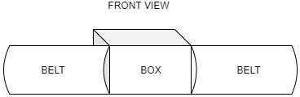

**Fig 3.5.2: The device in the water resistant box**

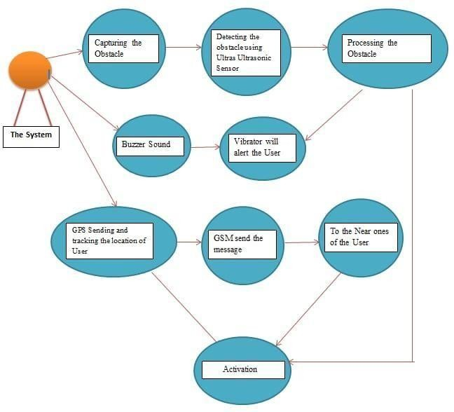

## Fig 3.5.2.1: System case Diagram

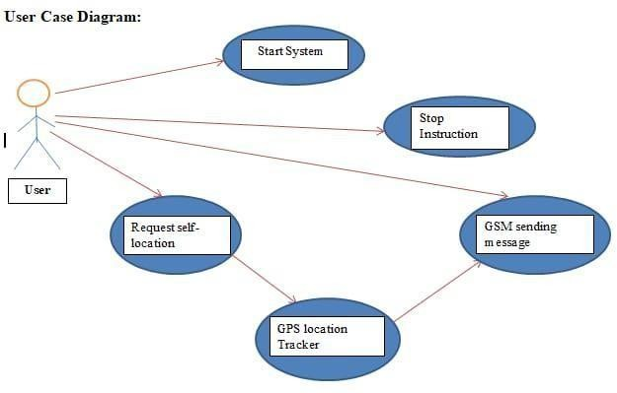

**Fig 3.5.2.2: User Case Diagram**

## CHAPTER 4: RESULTS AND OUTPUTS

## Proposed Model Outputs

The eyes are the fundamental component of the system for witnessing the outside world; their malfunction has a considerable influence on the outside world's knowledge comprehending capabilities. As technology has advanced, we may now afford a number of the same luxuries as other humans, yet individuals who are blind cannot. Blind persons commonly need on specific assistance or guidance to do their everyday activities. They are still dealing with a variety of issues in their lives. The suggested solution is a wearable band for visually impaired persons that may assist them in navigating obstacles and tracking their movement, which is then delivered to a specified family member. This will be outfitted with ultrasonic sensors made up of modules. The suggested technology functions as a third eye for blind persons.

As services and infrastructure have expanded, we have become so hedonistic that we have overlooked what a difficult life physically disabled people must endure. Eyes are the predominant sense organelles for monitoring and hearing the outside realm; their impotence has a detrimental effect on how efficiently the outside world can be comprehended. Moving about in such an environment is a particularly tough labor for blind persons since they cannot rely primarily on their own eye sockets and must overcome several obstacles. With the aid of this endeavor, they can resolve the issues they are experiencing. Primarily, the scope pertains to the Third Eye for making Blind people lives more easy and independent. The project's goal is for the gadget to be easily accessible to blind individuals since it is simple to use and administer. It can be made more sleek and small in the future.

As this project will assist blind people in not being dependent on others for their everyday duties, it is incredibly valuable and may be employed by individuals of all ages.

The third eye's implementation procedure for the legally blind is shown in Figure 4.1.1 below:

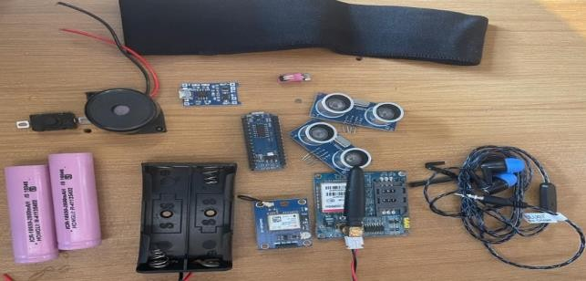

**Fig.4.1.1. Setup Model**

The figures 4.1.2(a) and 4.1.3(b) below, which are simple for people with visual impairments to utilize, show the results of the third eye again for the stone blind. The text message the person receives to find out where they were is shown in Figure 4.1.5. The precise spot is displayed on a map provided by Google in Fig. 4.1.6.

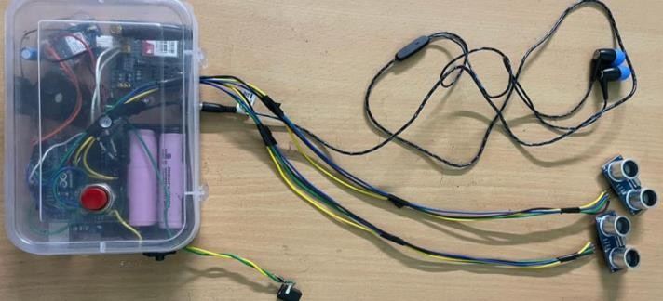

**Fig.4.1.2 (a). Working Model**

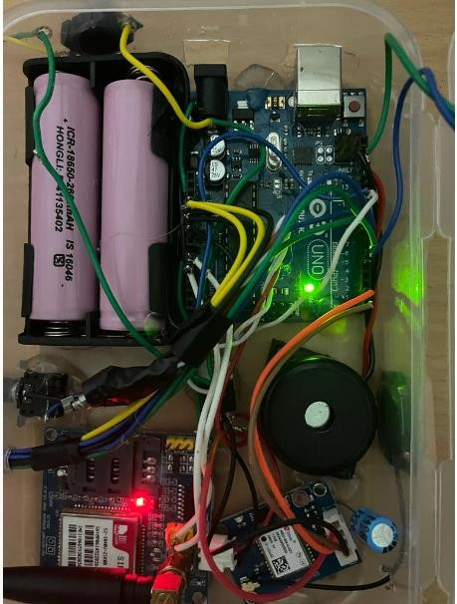

**Fig.4.1.3 (b). Working Model (Switched ON)**

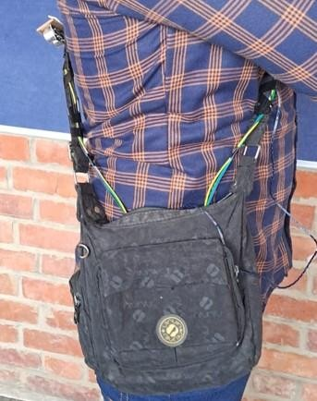

## Fig.4.1.4. Third Eye in the bag

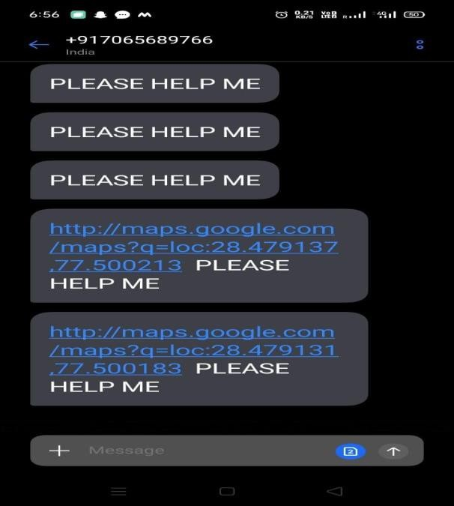

**Fig.4.1.5. Message Received**

As seen in the image, by just pressing the link provided in the text and utilizing GSM technology, the user's current location gets displayed on the map provided by Google. The person whose contact information is stored in the gadget can easily track the whereabouts of the blind user with **the aid of the text.**

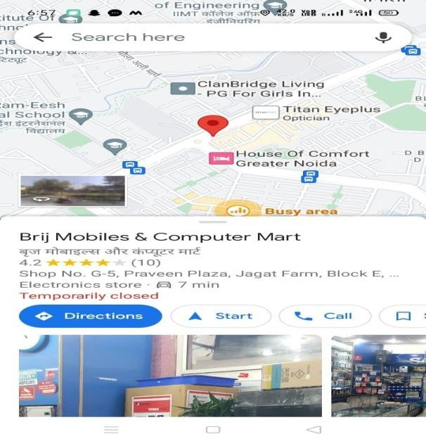

**Fig.4.1.6. Live location on Google Map**

## ESTIMATED BUDGET OF THE THIRD EYE

There are various devices on the market, ranging in price from expensive to inexpensive, and as a result, occasionally the quality suffers. Third eye is created with premium materials that keep the cost low so that anyone in need can easily buy it. For the reference, a projected spending plan has been created.

According to the device and sensors that are available in the market the cost is:

* Wires for the connections of the devices: Rs. 90
* Lithium-Ion battery (300mAh to 500mAh) Lifetime cycle of the battery is 2 to 3 years and the charge cycle of the battery is about 400–1,200 cycles. : Rs.450
* Buzzer : Rs.100
* GPS, 25X25 dimension NEO-6M: Rs. 1000
* GSM : Rs.1000
* Arduino-Uno, dimension 10 m diameter X 3.4 height: Rs 1000
* Vibrator Motor of Amplitude of 10m/s2 and frequency 12.5Hz: Rs 50
* Miscellaneous Cost: Rs.1000
* TOTAL COST = Rs. 3890

Due to their expensive pricing, not many people can afford the other devices that are available on the market for the blind, but the third eye is created in such a way that it can be budget friendly. The total cost is INR 3890, which is significantly cheaper than the other devices that are provided in this market for the blind. In contrast to other smart devices that are now available, such as smart sticks and pet dogs, the third eye is relatively simple to use; all a user needs to do is turn it on and they're ready to go.

## CHAPTER 5: CONCLUSION AND FUTURE IMPROVEMENTS

* 1. **Conclusion**

With their frequent reliance on others, blind people will find the solution provided by this initiative to be of tremendous value. Blind persons are exposed to a smart bag as part of the third eye for the Blind programme that emits a buzzing sound or other sensations, enabling them to move rapidly and confidently from one area to another. Additionally, blind people can be kept safe with a GPS tracking device that provides continuous location awareness.

## Future Scope

Third eye for the people who are blind is an improvement with the advice of multidisciplinary subjects like software engineering, gadget configuration, and health science that empowers vision challenged people to experience with speed and certainty by identifying nearby impediments utilizing ultrasonic waves and advising them with a signal sound or vibration [4].As the technologies get advanced we can now enjoy most of the comforts as normal humans but visually impaired people cannot.

The goal of this study was to produce information that blind people—who also happen to be others—would find very helpful. Thanks to the third eye for the Blind system, blind people can move from place to place quickly and with confidence by carrying an eye-catching bag that emits a buzzing sound or other sensations. Additionally, a GPS tracking device is available so that blind people can be located at all times for their safeguards.

## Limitation

Blind people usually depend upon specific support or help for them to do their daily work. They still face various difficulties in their life .In the past few years, there's been progress and innovation of several methods and technologies to enable people who are blind in accomplishing independent or unrestricted mobility about their circumstances without any of the assistance of another person. There are a few criteria , however they have certain limits and constraints .

The GPS is one of the main limitations of the proposed system because it only displays the user's most recent location without providing an exact location. Without a suitable network area, the device will not function. The third eye weighs a lot to wear because of all the devices and sensors it has; as a wearable, it is not small and svelte. It contains sensors, batteries, and other components that, under certain conditions of excessive use, may overheat.

## REFERENCES

1. Nikhil Manwani ,SajalGupta,PiyushAgrawal, Mandeep Singh Saini “Third Eye for the Blind Person”,vol 6 ,Issue 08, 2018
2. SakthiSankarV,RevanthG,SadamHussainM,.Manoj D R “Third Eye for Blind Using Ultrasonic Sensor”,vol 8,Issue 05, 2021
3. AzraBatool, ShaheenNaz “Third Eye for blind” ,vol 4 ,Issue2,2018
4. M Narendran,.SarmisthaPadhi ,AashitaTiwari“Third eye for the blind using arduino and ultrasonic sensors”,vol 3,Issue 1,1 Jan 2018
5. K.A Kupada.,Keeri B. Aigali, Rupal “Third Eye for blind persons using Node MCU Microcontroller and GPS” vol 9 ,Issue 6,6 June 2020
6. Mohammad Shiha, V.k Malvika Dileep,. K. M. Muhammed Rameez, AshishSoni, SheenaKurian K “Third eye - An App for Blind Assistance Using Machine learning” vol 7 ,Issue 2,2019
7. Samartha Kharwal,.SamerBaniAwwad, AparnaVyakaranam “Navigation System for Blind Third Eye” vol 8,Issue 5,March 2019
8. K. Maheswari, Dr. D. Subitha “Third Eye for the Visually Impaired Utilizing Arduino and Ultrasonic Sensor”,2020
9. Ramiro Velázquez ,EdwigePissaloux ,Pedro Rodrigo ,Miguel Carrasco ,Nicola Ivan Giannoccaro,.Aimé Lay-Ekuakille “ An Outdoor Navigation System for Blind Pedestrians Using GPS and Tactile-Foot Feedback ,2021
10. Przemyslaw Baranski, Maciej Polanczyk, Pawel Strumillo. A Remote Guidanc System for the Blind, IEEEd. Transactions on Remote Guidance, 2010, pp. 386- 390.
11. Pooja Sharma, Shimi SL, Chatterji S. A Review onObstacle Detection and Vision,

International Journal of Science and Research Technology. 2015; 4(1):1-11

1. Tahat AA. A wireless ranging system for the blind long-cane utilizing a smart-phone, in Proceedings of the 10th International Conference on Telecommunications.(ConTEL '09), IEEE, Zagreb, Croatia, June. View at Scopus. 2009, 111-117

[13]J. N. Madhuri and R. Ganesh Kumar, "Multiple-object Detection Method based on YOLO and ResNet Hybrid Networks," 2019 IEEE 4th International Conference on Advanced Robotics and Mechatronics (ICARM)

1. Y. M. Wang, Y. Li, and J. B. Zheng College of Infonnatics & Electronics Zhejiang Sci-

Tech University Hangzhou, China

1. Jing Tao, Hongbo Wang, Xinyu Zhang, Xiaoyu Li, Huawei Yang

State Key Lab. of Networking and Switching Technology 2017 6th International Conference on Computer Science andNetwork Technology (ICCSNT)

1. Maliha Khan Deptt. of Comp. Sc. and Engg, School of Engg. And Tech Sharda University, Gr.Noida, Uttar Prade2019 International Conference on Computing, Communication, and Intelligent Systems (ICCCIS)
2. Souhail Guennouni,Sidi Mohammed Ben Abdellah University School of Science and Technology

Signals Systems and Components LaboratoryB .P. 2202, 30000 Fez, Morocco 978-1-4799-5979- 2/14/$31.00 ©2014 IEEE

1. Chengji Liu1, Yufan Tao1, Jiawei Liang1, Kai Li1, Yihang ChenSchool of Mechanical Electronic and Information Engineering,China University of Mining and Technology (Beijing), Beijing, China 2018 IEEE 4th Information Technology and Mechatronics Engineering Conference (ITOEC 2018)
2. Erke ArÕbaú,Istanbul Technical University Faculty of Computer and Informatics Engineering Istanbul, Turkey 978-1-5090- 6494-6/17/$31.00 ©2017 IEE
3. Pooja Withanage1, Tharaka Liyanage1, Naditha Deeyakaduwe1, Eshan Dias1,Samantha Thelijjagoda Faculty of Computing, 2 Faculty of Business, Sri Lanka Institute of Information TechnologyNew Kandy Rd, Malabe, Sri Lanka978-1-5386-9418-3/18/$31.00 ©2018 IEEE
4. Daniel Barry University of Canterbury Christchurch, NewZealand 978-1-7281-4187- 9/19/$31.0©2019 IEEE
5. N. Saranya1, M. Nandinipriya2, U. Priya3 1,2,3 Assistant Professor, Department of Electronics and Communication Engineering, Bannari Amman Institute of Technology, Sathyamangalam, Erode. (India) 978-1-7281-0064-7/19/$31.00 ©2019 IEE

## ANNEXURE I

Research Paper for the said project has been accepted and presented in **IEEE Xplore/Scopus- indexed journals-**[**https://ieeexplore.ieee.org/xpl/conhome/10059246/proceeding**](https://ieeexplore.ieee.org/xpl/conhome/10059246/proceeding)

## Paper Title:

IoT Based Third Eye For The Stone Blind

## Abstract:

Eyes are the primary sense organs for seeing the outside world; their failure has a significant impact on the outside world's knowledge perceiving capability. As the technologies get advanced we can now enjoy most of the comfortsas normal humans but visually impaired people cannot. Blind people usually depend upon specific support or help for them to do their daily work. They continue to face a variety of challenges in their lives. The proposed solution is a wearable band for people with visual impairments that can support them in navigating challenges and barriers and tracking their coordinates, which is then sent to a particular member of the family. This will be adorned with ultrasonic sensors made up of software components. The proposed technology works as a third eye for blind people because they have outstanding senses. Avibrator sensor is used in the band to provide vibration in their hand whenever a component is nearby. Also when the sensor detects any object the buzzer will make sound. Therefore it is an automated device. The blind person's present position will be communicated to a particular person, who will be capable of locating individuals if they get lost and safeguarding them. This band will be of excellent assistance to blind individuals with regards to automatic identification and daily use.

## Authors: Sarah Irshad, Pravidhi Garkoti, Ankit Sharma, Dr.Parma Nand, Dr. Mandeep Kaur, Dr.Nitin Rakesh.

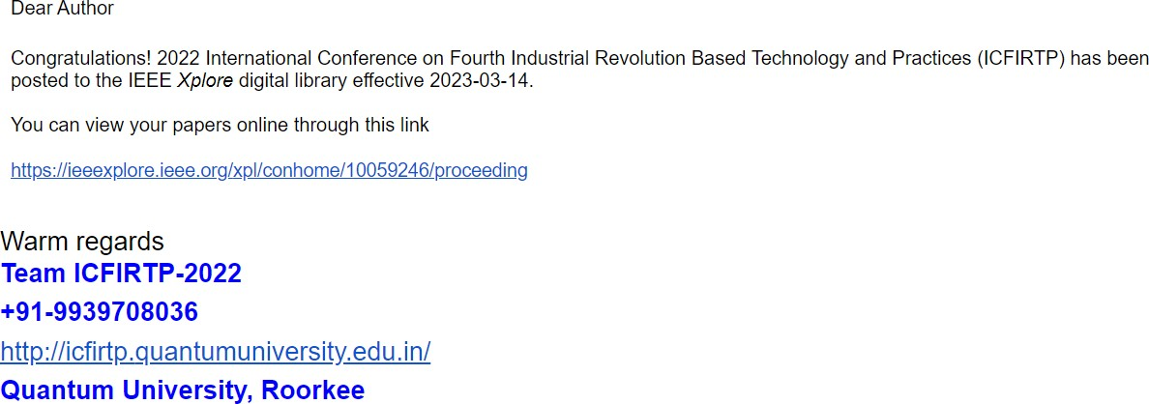

**ANNEXURE 2**

Hackathon participation for the said project in 5th Tech-novation Hackathon at Sharda University

## Paper Title:

IoT Based Third Eye for The Stone Blind

## Abstract:

The capacity to comprehend information from the outside world depends heavily on sight, which are the primary sense organs used to view it. As technology, we can now enjoy most comforts as regular people, but people with visual impairments cannot. In their largest part, blind people depend on extra help or support to complete their everyday tasks. They still encounter an array of hardships in their regular lifestyle. The proposed alternative is a wearable bag for people with visual impairments that can help them get around obstacles and challenges while also tracking their coordinates and transferring that information about a particular close relative. This will be decorated with software-based obstacle detection. Because of their extraordinary senses, blind people could benefit from the suggested scheme as a third eye. When a component is similar by, a vibrator transmitter in the bag causes vibration in their contrary. Additionally, the buzzer will sound when the sensor picks up any artifact. It is an automated instrument consequently. A particular individual, who is capable of finding people if they do get lost and trying to protect them, will be advised of the blind person's present position. Regarding automatic detection and daily use, the above bag will be a great help to blind people.

## Participants:

Sarah Irshad, Pravidhi Garkoti, Ankit Sharma.

